TECHNICAL PROJECT REPORT

# Title of Invention / Project: ***AVR glowing WALLET***

# Team Members / Inventors:

|  |  |  |  |  |  |
| --- | --- | --- | --- | --- | --- |
| **S. No.** | **Name** | **Department** | **Designation** | **Mobile** | **E-Mail** |
| 1. | Vikas Latiyal | BE-ECE | Student | 8003844934 | [Vikas.latiyal@gmail.com](mailto:Vikas.latiyal@gmail.com) |
| 2. | Rahul Sharma | BE-ECE | Student | 9931126710 | Rhrahul2000@gmail.com |
| 3. | Aman Satya Dubey | BE-ECE | Student | 9406588818 | imaman.satya@gmail.com |
| 4. |  |  |  |  |  |
| 5. | Khushal Thakur | ECE | Mentor | 9646030764 | khushal.thakur@cumail.in |
| 6. | Anshul Sharma | ECE | Mentor | 9478697475 | anshulsharma.ece@cumail.in |
| 7. | Kiran Jot Singh | ECE | Mentor | 9463909689 | kiranjotsingh.ece@cumal.in |
| 8. | Divneet Singh Kapoor | ECE | Mentor | 9878422653 | divneet.ece@cumail.in |

Section – 1 (IPR Related)

# ***Brief ABSTRACT:***

* ***Problem your project is solving***: Many times we have seen everyone faces a problem at night while opening their wallet for money purposes. Generally, at night when we get out from an auto and open our wallet, we find a lack of light there,and it is very difficult to see the money. Our project helps the customers to overcome from the lack of light at night .
* ***How are you solving that (solution):*** we have implemented a led light inside a wallet connected with sensor controlled by a switch.At night when their is no light,ldr sensor is not able to detect the light and led starts glowing and a person can easily see the money in the wallet.If the user don’t want the light in the wallet than he can just turn off the switch.

# Existing state-of-the-art and Drawbacks in existing state-of-the-art

(*Brief background of the existing knowledge*)

|  |  |  |
| --- | --- | --- |
| **S. No.** | **Existing state of art** | **Drawbacks in existing state of art** |
| 1 |  |  |
| 2 |  |  |

# Novel/Additional modifications that you can propose to improve upon drawbacks

*(List down the features)*

* Feature 1
* Feature 2

# Advantages

(*List down the advantages, if each feature is incorporated)*

* Adv 1 there would be no need to search light at night to see the money in the wallet or purse

# Block Diagram

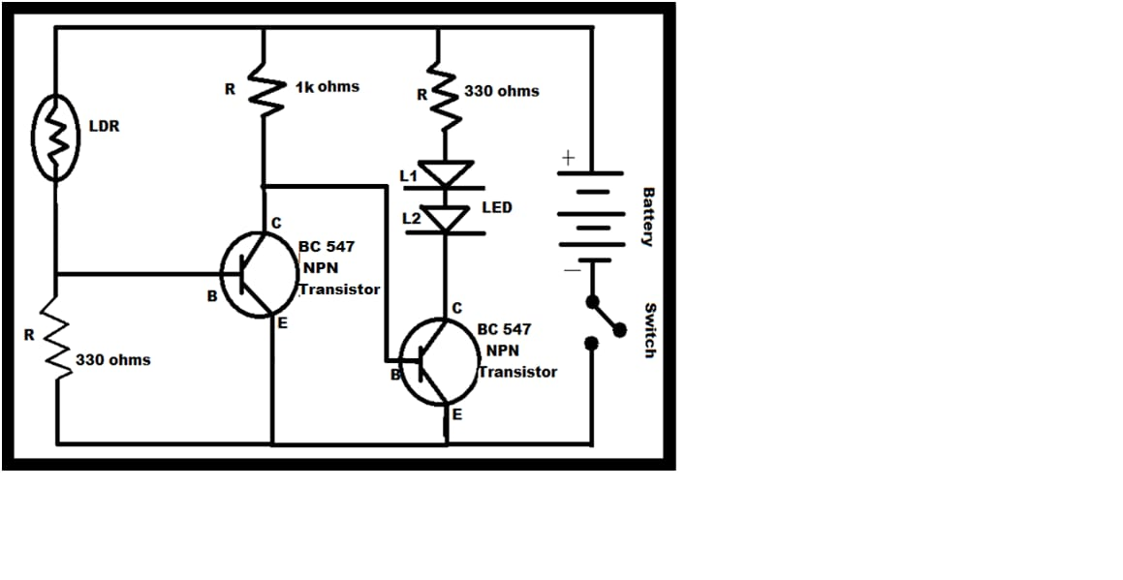

Section – 2 (Real Project)

# ***Materials***

led , ldr sensor ,on- off switch, wire, wallet,3v battery

# ***Circuit Diagram***

